

Name:Rubini Raju

Login Id:rubini@oasis-portal.com

Course Title:Tourism and Hospitality

Subject Code:BHM04

Submitted date:11/09/2017

TABLE OF CONTENTS

|  |  |  |
| --- | --- | --- |
| NO | DETAILS | PAGE |
| 1 | EXECUTIVE SUMMARY | 2 |
| 2 | INTRODUCTION | 3-4 |
| 3 | ASSIGNMENT QUESTION |  |
|  | PART 1 | 5 |
|  | PART 2 | 6-7 |
|  | PART 3 | 8-11 |
|  | PART 4 | 12-13 |
| 8 | CONCLUSION | 14 |
| 9 | REFERENCES | 15 |
| 10 | APPENDIX | 16 |

1

Executive Summary

In the module, I covered the topic about Tourism and Hospitality within a Hospitality Management. In starting part, we can see the introduction of Tourism and Hospitality. What is Tourism and Hospitality and how importance in hotel industry? In first part,I studied the Tourism and Hospitality and explain the undertanding about Hospitality industry in Tourism and Hospitality. In the second part, I will brief the different type of Tourism categories and define Tourism. Third part, I describe the lodging accommodation and types of Hotel accommodation. Finally, I will explain the Significant of Entertaiment in this industry.

2

INRODUCTION

The [hospitality industry](http://www.wisegeek.com/what-is-the-hospitality-industry.htm) is much broader than most other industries. The majority of business niches are composed of only a handful of different businesses, but this industry applies to nearly any company that is focused on customer satisfaction and meeting leisurely needs rather than basic ones. While this industry is very broad, there are some defining aspects that are important to understand.

### Defining Aspects

One of the most defining aspects of this industry is that it focuses on customer satisfaction. While this is true of nearly every business, this industry relies entirely on customers’ being happy. This is because these businesses are based on providing luxury services. Very few hospitality businesses provide a basic service that people need, like food or clothing.

Another defining aspect of this industry is its reliance on disposable income and leisure time. For this reason, the majority of these businesses are for tourists or rich patrons. If disposable income decreases due to a slump or recession, then these are often the first businesses to suffer because customers won’t have the extra money to enjoy their services.

### Different Businesses

Most people think that hotels alone belong to the hospitality industry, but hotels are only one sector of this industry. Many forms of transportation that cater to tourists are also part of this business world. For example, this niche includes airlines, cruise ships and even fancier trains. Restaurants, general tourism and event planning also belong to this niche.

Some of these businesses partially belong to the hospitality industry. For example, a fast food restaurant would be considered convenient. A restaurant that provides fancy food with amazing service would be providing a hospitality service.

### Level of Service

Regardless of the business, this industry relies heavily on providing an excellent level of service. Customers are visiting the business to get away from their troubles. A bad experience might keep them from returning ever again. Brand loyalty is very important to these customers, so the associated companies do their best to provide the best service.

Companies hire employees based on skill and behavior. Most of these employees are great with customers, and they can flawlessly give the customer what he or she needs.

### 3

### Themes

Another defining aspect of the hospitality industry is its theme. This doesn’t apply to every business in this industry, but many of them use a certain theme to attract customers. For example, a fancy restaurant might have a Mediterranean theme to attract customers who like that type of food and atmosphere.

Not only does this set the business apart from competitors, but it also allows customers to judge the business on another level. Hospitality businesses that provide an authentic theme are often appreciated more than general hospitality businesses. If the above restaurant cooks authentic Mediterranean cuisine and uses the proper decorating elements, then this will make customers happy and more willing to visit the business.

A hospitality business doesn’t need a theme, but the vast majority of them use one because customers love themed businesses.

### Conclusion

While this is a very broad industry that can incorporate many different businesses, there are some defining elements that set it apart from similar businesses. Not only do these companies focus on service and luxury, but they also depend on disposable income and giving customers what they want. The broad-reaching hospitality industry ensures that every customer is happy because brand loyalty is essential.

4

Assignment Questions

Question 1

Define the Tourism and Hospitality,explain your undertanding about Hospitality industry.

The industry of providing customer service to travelers or strangers. Hospitality professionals generally work in administrative or management positions in a service-based environment, and they are responsible for overseeing the operations and success of an establishment, such as a hotel or restaurant. The hospitality and tourism industry is diverse, and includes many locations including RV parks, food establishments, recreational facilities, campgrounds, boarding houses and youth hostels. While the overall goal of a hospitality professional is to ensure that guests and customers have pleasurable experiences, they can also be responsible for operations, such as hiring and training new staff; supervising office and financial administration; housekeeping, maintenance, and security staff; and marketing.

Hospitality professionals also distribute funds, set room rates, and ensure that the service standards of the business are met. General duties for hospitality professionals vary depending on the size of the business and the amount of staff available. In larger operations, there is usually a hierarchy of general managers, assistant managers, and supervisors who work to perform operational tasks relating to their areas of expertise. In a smaller business, the hospitality professional performs these tasks directly.

Sometimes hospitality professional positions are specialized. For example, some focus on managing the front office, while others can be responsible for convention services or financial administration. If a hospitality professional is employed in a specialized position, he or she must have excellent communication skills and the ability to work well alongside coworkers in other areas of the business.

Employers prefer applicants with a bachelor's degree in business or hotel or hospitality management, but a liberal arts degree along with hospitality experience may also be acceptable. Smaller establishments may accept applicants with a certificate or associate's degree in hotel, hospitality or restaurant management.

5

Question 2

Brief on different type of Tourism categories and define Tourism.

Traveling is one effective way to see the world, experience new cultures and meet new people at the same time. For many tourists, however, traveling accomplishes many other purposes that don’t even have anything to do with the joy of visiting a new place. This is why there are many different types of tourism that explain why tourists choose a particular destination and the things that they expect to do when they are there.

Perhaps the most common type of tourism is what most people associate with traveling: **Recreation tourism**. This is when people go to a place that is very different from their regular day-to-day life to relax and have fun. Beaches, theme parks and camp grounds are often the most common places frequented by recreational tourists

If the objective of one’s visit to a particular place is to get to know its history and culture then this type of tourism is known as **cultural tourism**. Tourists may visit different landmarks of a particular country or they may simply opt to focus on just one area. They may also attend festivals and ceremonies in order to gain a better understanding of the people, their beliefs and their practices.

For tourists who want to see wildlife or bask in the joy of just being in the midst of nature, **nature tourism** is the answer. Ecotourism and nature treks are all part of this kind of tourism. Bird watching, for example, is one activity that nature tourists are fond of doing. What marks this kind of tourism is that it is environmentally responsible, has low impact and advantageous to the local community.

Many people today are stressed out in the corporate rat race and in need of rejuvenation. Thus, they go on trips that refresh their souls and spirits. This is called **pleasure tourism** and usually includes yoga workshops and detox vacations, among others. Others, however, de-stress by engaging in a particular sport. Called **sports tourism**, travelers here target places which are known for a particular sporting facility. Skiing, for example, is a type of sports tourism.

Also included in this category are those who go to a destination to experience a sports spectacle such as the Olympics, FIFA World Cup and others.

**Religious tourism** is another type of tourism where people go to a religious location or locations to follow the footsteps of their founder or to attend a religious ceremony. Catholics, for example, go on pilgrimages in the Holy Land to experience the paths where Jesus walked.

**Medical or health tourism** is a relatively new type of tourist activity where the main focus of the travel is improving one’s health, physical appearance or fitness.

6

For instance, certain countries promote the expertise of their doctors and surgeons in the field of cosmetic surgery and invite foreigners to have their liposuction, facelift, nose lift and other forms of cosmetic procedures to be done there. Medical tourism also incorporates aspects of recreation tourism where the patient goes to a relaxing getaway to recover from the procedure.

**Adventure tourism** is another type of tourism that is catered for those who want to do more than just visit regular tourist sites. These kinds of trips involve challenging activities like rock climbing, mountain climbing and wild water rafting.

It should be noted that there are no strict delineations when tourists go on their trips. These kinds of tourism often overlap so it’s not unusual for travelers to experience more than one type of tourism in one vacation.

7

Question 3

Describe the lodging accommodation and types of Hotel accommodation.

In land scarce Singapore, apartment living is the norm, with condominiums offering full facilities (pools, gyms, 24 hour security, and tennis courts) the most popular expat accommodation option. However, houses are also available and range from homes with pools and large gardens to terraced heritage properties (‘shophouses’) and everything in between.

A brief description of the most commonly used terms used to describe housing options:

APARTMENTS:

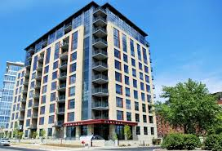

Condo (Condominium) – Apartments with facilities such as swimming pools, tennis courts, gyms, children’s playgrounds, BBQ areas and 24 security or concierge service. The size of the individual apartments can vary a great deal depending on when they were built, more recent developments tend to feature smaller units, whilst apartments in older blocks are often much larger

.

Penthouse – The largest unit in the block of condos/apartments. Usually on the top floor with a private roof garden.

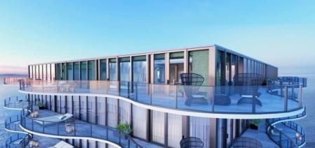

Duplex – A two storey apartment.

8



High Rise – A high rise apartment, usually without any of the condo facilities described above.



Low Rise – A low rise apartment, again usually without the trimmings.



Maisonette – An apartment with two levels.

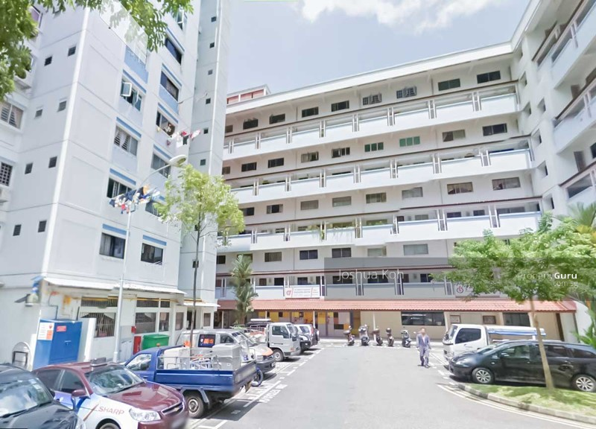

Townhouse – A house that shares the same compound and/or facilities (if any) with other houses.



9

Walk-up – Low rise apartment without a lift.

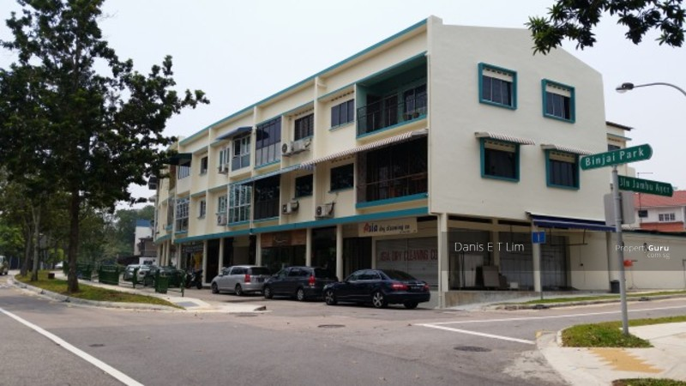

HOUSES:  Usually referred to as ‘Landed’ Property (i.e. property with garden and sometimes a swimming pool).

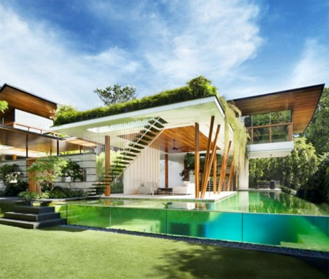

Bungalow – A house that shares no land or facilities with any other, not necessarily a single storey dwelling. Many styles of bungalow are available, from colonial to Balinese to ultra-modern.

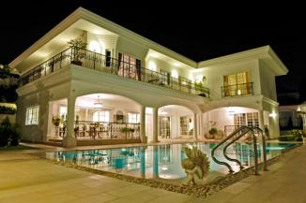

Black and Whites‘ – Colonial era homes built to house the British military and their families, so called because of their distinctive paint finish (white walls with black trim). These historic homes are for the most part owned and managed by the Singapore government and are highly sought after by many expatriates as most offer large gardens, hard to find in built up Singapore. Tenancies can be obtained via a bidding system.

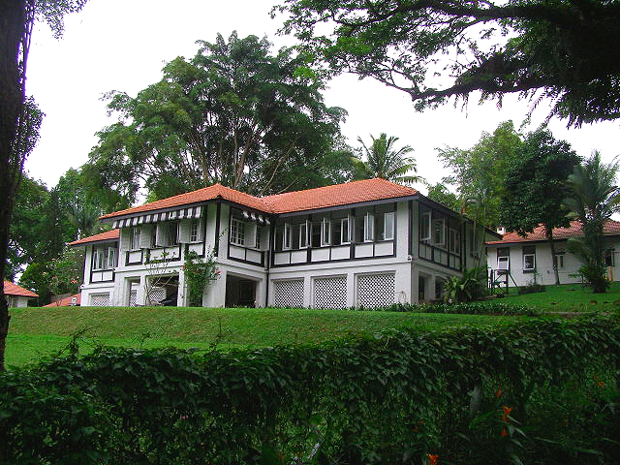

10

Semi-detached – A pair of houses, joined side by side, usually on smaller plots of land.



Terrace house – A row of houses joined side by side, minimal garden.



Corner or end terrace – Corner terrace house. The last house of the row of  houses that are joined.

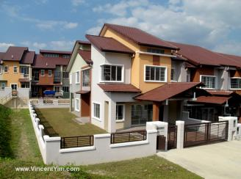

Shophouse – Unique to Singapore, built for the most part during the colonial era for Chinese merchants and their families. In the past twenty years these unique homes have undergone something of a revival, with their unique style capturing the imagination of many architects and interior designers

.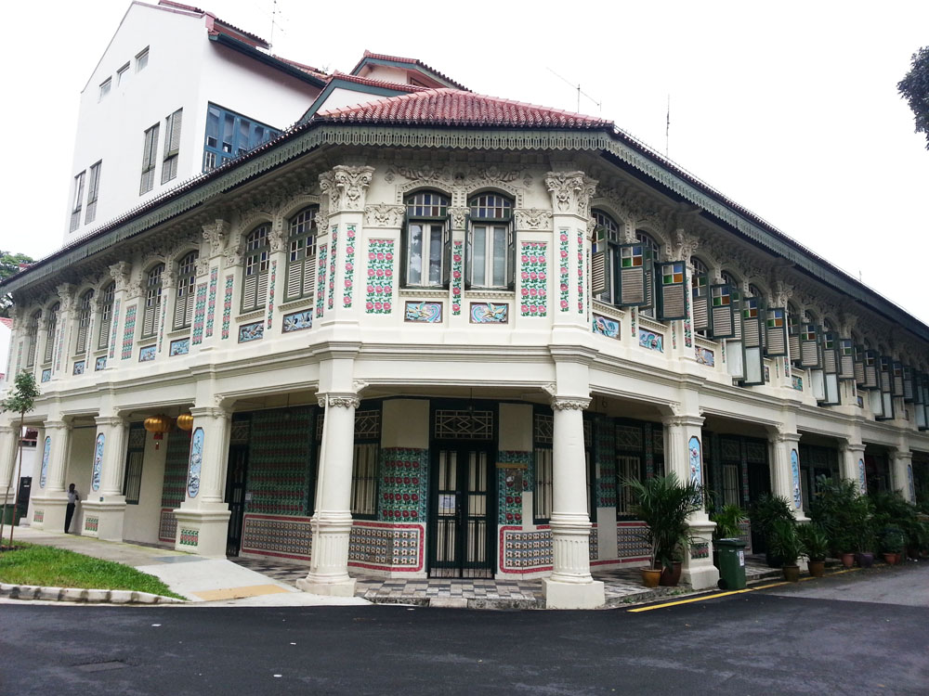

11

Question 4

Explain the significant of Entertainment in this industry.

Consider a career in Recreation and Entertainment. This industry is projected to be the fastest growing tourism industry by 2015 and offers some of the most unique work and career opportunities. From working on a ski hill to event coordination, this industry has lots to offer!

### Outdoor Adventure and Ecotourism

Many travelers seek adventure, challenge and excitement in the fabulous outdoor settings that Canada has to offer. Hiking, cycling, mountaineering, canoeing, kayaking, sailing, horseback riding, river rafting, scuba diving, sky diving, snowmobiling, and nature and wildlife viewing are just some of the activities included in this industry of the tourism sector.

People who work in this industry combine special expertise with their love and knowledge of the outdoors. As with all front line tourism occupations, employees must enjoy working with people and be skilled at understanding and meeting individual needs. In addition, employees must respect the environment and help others to respect it as well, to preserve and protect the ecology for the future.

### Ski Resorts

Winter may come but once a year, yet you can be part of it year round! Canada’s more than 300 alpine ski areas attract millions of domestic and foreign tourists annually and there are hundreds of ski clubs serving this industry. It employs people who sell clothing and ski equipment, maintain and repair facilities and equipment, operate equipment and teach people to ski.

### Golf and Tennis Facilities

Large numbers of Canadians and foreign visitors love Canada’s many golf and tennis facilities. As with ski resorts, this industry needs employees to sell clothing and sports equipment, maintain and repair facilities and equipment, and train players.

### 12

### Parks and Attractions

In addition to Canada’s 38 national parks and 792 national historical sites, all provinces and territories have regional parks. Most urban and rural municipalities also have parks and habitat protection areas. Attractions can include historic sites, heritage homes, museums, halls of fame, art galleries, botanical gardens, aquariums, zoos, water and amusement parks, casinos and cultural attractions. Some attractions are educational; others are solely for entertainment – but all of them can give you the ability to embark on a great adventure…a job or career in tourism!

Employees in this industry work full and part time in a variety of positions in planning, marketing, selling, maintaining, promoting, patrolling, interpreting and training.

### Marine Facilities

Across Canada, Canadians and foreign visitors alike enjoy water and water-based activities, such as fishing, swimming, sailing, windsurfing, water-skiing, canoeing, and sea-dooing. Related businesses include marinas, tour boat excursion or rental operators, sport-fishing lodges, and fly-in fishing camps. On both the east and west coasts, there are marine businesses offering exciting activities such as whale-watching, kayaking and deep-sea fishing. This sector requires employees as guides, instructors, business operators and more.

13

**Conclusion**

how much I have learned the basics of hospitality and tourism industry ; which is like can different between general purposes of it and its functions. And now I’m able to differences between the two industries hospitality industry and tourism industry . I also could be able to describe the difference of their importants to customers, such as entertainments,accommodations,facilitiesand more, as well as identify the main impotant and needs of the hospitality industry and tourism industry to the customers and their purposes.

14

**References**

Chon, K. & Sparrowe, R T (2000). Welcome to Hospitality...an Introduction.United

States: Thomson Learning

Walker, J R. (2006).Introduction to Hospitality.

United States: Prentice Hall

Walker, J. R. (2010). Introduction to Hospitality, 3rd

ed. Upper Saddle River, NJ: Pearson Prentice-Hall.

**<https://www.google.com.sg/search?biw=1366&bih=638&tbm=isch&sa=1&q=tourism+industry&oq=tourism+industry&gs_l=psy-ab.3..0l2j0i67k1j0.152412.155431.0.156708.8.8.0.0.0.0.297.1573.0j3j4.7.0....0...1.1.64.psy-ab..1.7.1567...0i7i30k1j0i13k1.lwSqmlWKwpI>**

**<https://www.google.com.sg/search?source=hp&q=meaning+of+hospitality&oq=meaning+of+hospitality&gs_l=psy-ab.3..0l4.3372.16009.0.17286.24.23.1.0.0.0.538.5078.0j9j6j4j1j1.21.0....0...1.1.64.psy-ab..2.22.5080...0i131k1j0i10k1.tAK79h85m-I>**

**<https://www.google.com/search?q=what+is+the+tourism+and+its+important&oq=what+is+the+tourism+and+its+important+&aqs=chrome..69i57.47025j0j7&sourceid=chrome&ie=UTF-8>**

<https://www.google.com/search?q=entertainments+inhospitality+industry&oq=entertainments+inhospitality+industry&aqs=chrome..69i57j0.23377j0j7&sourceid=chrome&ie=UTF-8>

**[https://www.google.com/search?tbm=isch&q=5+different+entertainments+in+hospitality+industry&spell=1&sa=X&ved=0ahUKEwic8YXJpprWAhUNT48KHSU1BZQQvwUIIigA&biw=1366&bih=638&dpr=1#imgrc=lZaOxqtql4wmtM](https://www.google.com/search?tbm=isch&q=5+different+entertainments+in+hospitality+industry&spell=1&sa=X&ved=0ahUKEwic8YXJpprWAhUNT48KHSU1BZQQvwUIIigA&biw=1366&bih=638&dpr=1" \l "imgrc=lZaOxqtql4wmtM):**

15Appendix

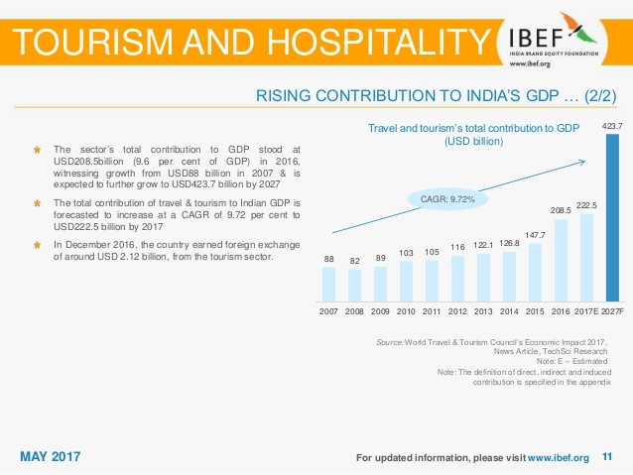

16